The Many Variations on Model Rockets which Result in Greater Altitude
A Study in Aerodynamics and the Engineering Behind Model Rocketry
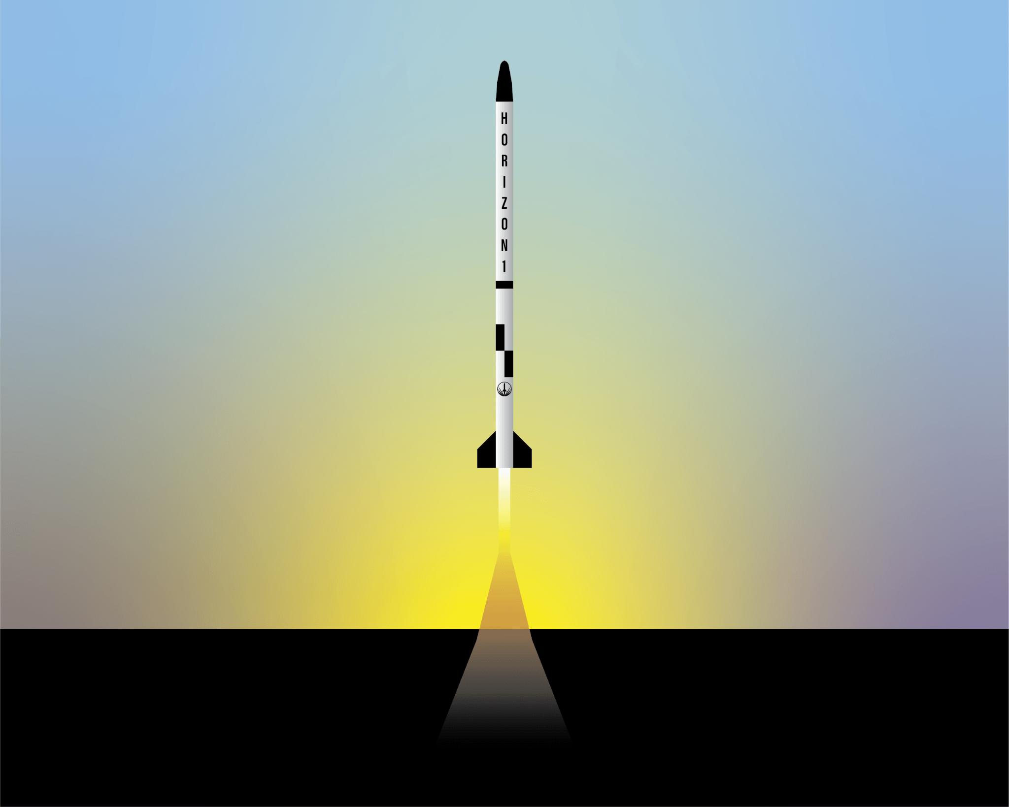
Josiah A. Wilson
December 1—Present

Abstract:
Rocketry is considered by many to be the pinnacle of engineering and human ingenuity. My goal in this project was to find the ideal airframe design to reach the highest height possible for a subsonic model rocket airframe regarding aerodynamics, weight, stability, reusability, modularity, cost, and structural integrity. To achieve modularity and reusability, I did not use any adhesives but rather used M3 and M4 bolts. I also 3D printed all of the components besides the fins and airframe tube. The airframe tube was made from kraft paper, and the fins were laser cut. The three fin materials that I tested were polycarbonate, aluminum, and Delrin. I tested three types of nose cones: parabolic, ogive, and conical. For measuring the height to the extrapolate aerodynamic efficiency, I tried using an accelerometer/gyroscope unit.
Due to noise in the accelerometer output, I was unable to gather adequate data, and I moved on to trying a barometric pressure sensor. Unfortunately, the pressure sensor had difficulty connecting to my flight computer, so I bought a more expensive, but working model rocket altimeter. One difficulty in designing the flight computer assembly was creating a lightweight and space-efficient mount that would still be strong enough to withstand potential impacts. Another challenge was testing. Due to weather, inefficiencies in flight preparation, and deadlines, I was unable to conduct actual flight tests and resorted to using simulations. This led to unusable data for the nose cone types. In my testing, I found that the Delrin and polycarbonate fins resulted in the highest flight, and aluminum the lowest. I concluded that this is due to weight.
Constructing a wind tunnel will be the next step in engineering, as well as attempting more flights. For future designs, I will upgrade the flight computer with Bluetooth control, a dead-reckoning altimeter, and lighter parachute deployment mechanisms, among other things.

Engineering Goal:
Design a subsonic model rocket’s airframe to reach the highest height possible regarding aerodynamics, weight, stability, reusability, modularity, cost, and structural integrity.

Engineering Process:
- Determine the Qualities of the Rocket
  - Qualifications: The rocket must be capable of reaching high speed for a sustained period to test aerodynamics, however not high enough speed to break the sound barrier, because that would create shock cones which would interfere with the aerodynamics of the subsonic airframe. To reach high speeds, the rocket must be aerodynamic, as well as stable. Based on my research, the best way to stabilize the rocket consists of utilizing aerodynamics in the form of fins and shifting the center of aerodynamic pressure behind the center of mass along the Z-axis (see diagrams 3, 4, and 5 for info on the axis of measurement). In order for the rocket to be reusable to the highest degree possible, I have decided to use no sandpaper, glue, or adhesives if possible.
  - Nose Cone: Having an aerodynamic nose cone reduces the aerodynamic pressure at the top of the rocket. According to my research, the most aerodynamic shape of the nose cone for a rocket traveling at subsonic speeds (as previously stated, I intend on not exceeding the sound barrier) is a parabolic shape. In addition to this, I will also try Tangent Ogive and Conic shapes
    - Acquisition and Manufacturing: There are a few ways I found to get a parabolic(or similar) shaped nose cone, however the best way that I have found is through the use of 3D printing. By 3D printing the nose cone, I will be able to change the mass through infill density and infill patterns, as well as by changing the material. I will also be able to change where the center of mass of the nose cone is, which will help to move the center of mass of the whole rocket. In addition to the previously stated reasons, I will also be able to change the shape of the nose cone, which is perhaps the most important part of this stage of design, due to that I want an aerodynamic nose cone. Other methods of manufacturing a nose cone include using a CNC machining method(which I do not have access to in my budget), hand carving from wood(which will not give me the symmetry or precision required), and using composites such as carbon fiber or fiberglass(which I do not have experience with, and which tend to be expensive). One other source of nose cones that I considered was purchasing them off the internet. If I had done so, I would have had to contend with shipping times and pricing, as well as limited options. Ultimately, I chose 3D printing because it is fast, cheap, has the highest precision, and is the most adjustable.
  - Fins: Using fins at the base of the rocket along the Z axis does two things: 1) It shifts the aerodynamic pressure in the negative direction along the Z axis; 2) It causes the rocket to resist changes in rotation on the X and Y axis when traveling with positive velocity along the Z axis. This is due to Newton’s Third Law of Motion (See diagram 6).
    - Fin Shape: For the fins, I needed a shape that was going to have a high surface area to maintain maximum aerodynamic stability, but also is aerodynamic when traveling directly along the Z axis, so drag is reduced when the direction is correct. In addition to these requirements, I wanted the fins to provide some support for the stability of the rocket when resting on the launch pad, and when landing to protect the other parts of the airframe from being damaged. For this task, I decided to use a clipped delta shape (See diagram 1).
    - Fin Modularity: One of the primary goals in the creation of this rocket was that of reusability. With this rocket, I wanted to specifically reuse the fins, because manufacturing additional fins is more expensive and time-consuming than adding custom attachment points to the original fins. In designing the fins, I decided to use a rectangular tab that would extend into the airframe of the rocket. Spaced evenly along the longest portion of the rectangle, and centered along the shorter, I placed three holes through the entire thickness of the fin, each of which was of a diameter to allow M3 bolts and their threads to pass through, however with little tolerance. (See Diagram 1) This allows for connection to an apparatus inside the rocket through the use of M3 bolts.
    - Acquisition and Manufacturing: There are few ways one can go about acquiring custom-designed model rocket fins, so I had to keep that in mind when researching and designing the fins. The options I saw as possibilities were as follows: 3D printing with my 3D printer; CNC machining of wood or similar material through an online service; laser cutting materials through an online service; 3D printing through an online service. The options that fulfilled my needs the best were CNC machining and laser cutting through an online service. The reasons for this decision were strength and precision. With a laser/CNC cut fin, I would have access to materials much stronger than hobbyist-level 3D printing is capable of, as well as greater variety, and also the precision of a commercial laser cutter. With these things in mind, I conducted research and found a site called Sendcutsend.com, which does custom fabrication of laser/CNC cut parts at a low price.
    - Fin Material: Since I chose to use Sendcutsend’s CNC/laser cutting capabilities for the fins, I had many fin materials to choose from. I decided not to use any variety of steel, because, while strong, steel’s strength-to-weight ratio does not become applicable until applied at a higher level of rocketry, such as for a liquid fuel engine. There were two other possible metals that I could use for the fins, and those were aluminum (due to its low weight), and titanium (due to its low weight and high strength). In addition to metals, I also had the option of composites and plastics. I had wanted to try carbon fiber, Grade 5 titanium, and G10/FR-4, but I decided not to because of the pricing of the components of such materials. I ended up choosing 7050 aluminum, Delrin, and Polycarbonate.
  - Motor Mount: To attach the fins, I designed a mechanism to allow the fins to attach to an apparatus inside the body of the rocket, as mentioned above. Because the fins would be positioned at the base of the rocket, near the motor, I needed to design a mounting mechanism that would allow both objects to attach to the rocket. For this task, I again chose 3D printing, for the same reasons as stated above for the nose cone, except for aerodynamics. The motor mount consists of a main cylinder, with a slot in the middle for the motor. Outside of that, there are slots for the fins and for the M3 bolts and nuts that go through the fins, in order to secure them to the mount. Also, there are 8 slots for the M4 nuts to secure the mount in place according to the airframe. See Diagrams 11 and 12 for a visual representation.
  - Coupling: Since I was not using the traditional method of parachute deployment, I needed a way to vent the pressurization charge without damaging the electronic components in the rocket. Also, since I was using two body tubes, I needed a way to connect them. Traditionally, a slightly smaller tube is used with glue, but since I am not using glue, I had to design a different method of attachment. I opted for a 3d printed adapter that had slots for four M4 nuts mounted at 90° from each other so that M4 bolts could be screwed through the airframe tube to secure it in place. This ensured modularity and a quick replacement method if anything broke. I added a block between the two airframe tubes and a small section between the coupling sections that was flush with the outer tubes. In that small section, I added four ports to vent the pressurization charge downward at about a 45° angle, as well as two ports for letting air into the upper chamber for the barometer reading.
  - Flight Computer: To link all of the aspects of the rocket (ignition, measuring altitude, directional orientation, velocity, parachute deployment), I needed an electronic computing device. For this task, I turned to the Raspberry Pi Pico, because of its small size and low price, as well as its use of the python coding language. For the following sections, a basic understanding of the python coding language and circuitry is required. See Diagram 7 for a visual representation of the Raspberry Pi Pico pinout. In order to mount the flight computer, I 3D printed a mount, which allows for individual replacement of each of the mounts for the electronic sensors. It connects to the rocket airframe using M4 bolts.
    - Altitude Measurement: To measure accurately the height that the rocket reaches, I decided to use an inertial measurement unit, or IMU, to measure acceleration, and based on those measurements, calculate velocity and distance. In the case of the rocket tipping over mid-flight, I also needed a way to measure axial rotation. After doing some research, I found a microchip electronic unit that would measure both acceleration along the X, Y, and Z axis, as well as angular velocity around the X, Y, and Z axis. This unit was the MPU6050, which was small, lightweight, within my budget, and interfaced with my flight computer. After some testing and troubleshooting, I initially found that the acceleration readings have too much noise to get accurate readings. Because of this, I acquired an atmospheric pressure sensor, called the BME280. Because this can measure the current air pressure, I can then apply the pressure altitude equation to solve for the altitude. By keeping the MPU6050, I can see the change in angle over the flight, and from there see which combination of independent variables results in my rocket going the highest.
    - In the end, I ended up using an Estes altimeter mounted in the nose cone of the rocket. By having an accurate measurement method, I am able to see the difference between my self-made measurements and the actual, and theoretically thus change my methods to more accurately match the real value.
  - Launch Pad: In order for the best possible launch, I needed a way to start the rocket as level as possible (or, if there is wind, to hold it at a specific angle). Since I was not sure if the ground at the launch site would be level or flat, I decided to make the launch pad a platform with adjustable legs. Through adjusting these legs, could ensure that the launch pad was at the desired angle. For the main platform of the launch pad, I used a sheet of ½ inch birch plywood, which I then cut down to a 1 foot by 1 foot square and sprayed with heat resistant spray-paint. The legs consisted of four ½ inch bolts, of 6-8 inch length, which slid through holes in the corners of the main platform. The method of securing them consisted of two bolts and two washers, both on either side of the wood. The head of the bolt was on the lower side of the platform, and formed a foot. By threading the nuts along the bolt, I was able to make a longer or shorter length underneath, resulting in the ability to adjust the angle of the launch pad regardless of terrain. I then 3D printed a mount which both secured a 4 foot long 5mm steel rod (guide rail) to the upper side of the launch pad, and stabilized the rocket as it was sitting motionless on the launch pad to ensure accurate gyroscope calibration.
  - Decals and Paint: For the decals, I used sticker paper that I printed things on which I then cut to fit on the rocket. I found that the thickness of the paper was thin enough that in theory, it should not affect the aerodynamics as much.

Variables:
- Independent Variables:
  - Fin type
    - Polycarbonate (Coefficient of friction = 0.31)
    - Delrin 150 (Coefficient of friction = 0.1-0.3)
    - 7075 aluminum (Coefficient of friction = 0.7)
    - PLA?
  - Nose cone shape
    - Conic
    - Parabolic
    - Tangent Ogive
- Dependant Variables:
  - Altitude achieved
  - Max velocity
  - Max acceleration
  - Coefficient of drag
  - Caliber of stability
  - % difference from apogee in a vacuum
  - Change in direction
    - X-axis
    - Y-axis
    - Net change (XY vector)
- Uncontrolled Variables:
  - Temperature
  - Pressure at sea level
  - Humidity
  - Wind

Essential Equations:
- $s=d÷t$ where $s$ is speed, $d$ is distance, and $t$ is time.
- $v=d÷t$ with direction where $v$ is velocity, $d$ is distance, and $t$ is time.
- $v_{i}=initial velocity$
- $v_{f}= final velocity$
- $Δv=v_{f}+v_{i}$
- $a=Δv÷t$
- $F=m⋅a$

Total Materials List:
- Estes D12-3 rocket motors (x1 per launch)
- Raspberry Pi Pico
- MPU6050 inertial measurement unit
- Solderless Breadboard (for prototyping)
- computer capable of running Thonny IDE
- Cable to connect raspberry pi pico and computer
- x4 polycarbonate fins 3.0mm thick (See Diagram 1 for measurements)
- x4 Delrin 150 fins 3.18mm thick (See Diagram 1 for measurements)
- x4 7075 Aluminum fins 3.18mm thick (See Diagram 1 for measurements)
- FDM 3D printer
- PLA filament
- Model rocket body tubes x2 per rocket (Find at https://www.apogeerockets.com/Building_Supplies/Body_Tubes/Low_Power_Tubes/41mm_x_18_Body_Tube_Estes_BT-60_Size)
- Model rocket body tube connector (find at https://www.apogeerockets.com/Building_Supplies/Body_Tube_Couplers/Standard_Couplers/AC-41-6_BT-60_Coupler)
- Parachute assembly (See also: Title of Zeke’s Project, by Ezekiel Sperling)
- Launch Pad (See: Diagram 10, Launch Pad)

Diagrams:
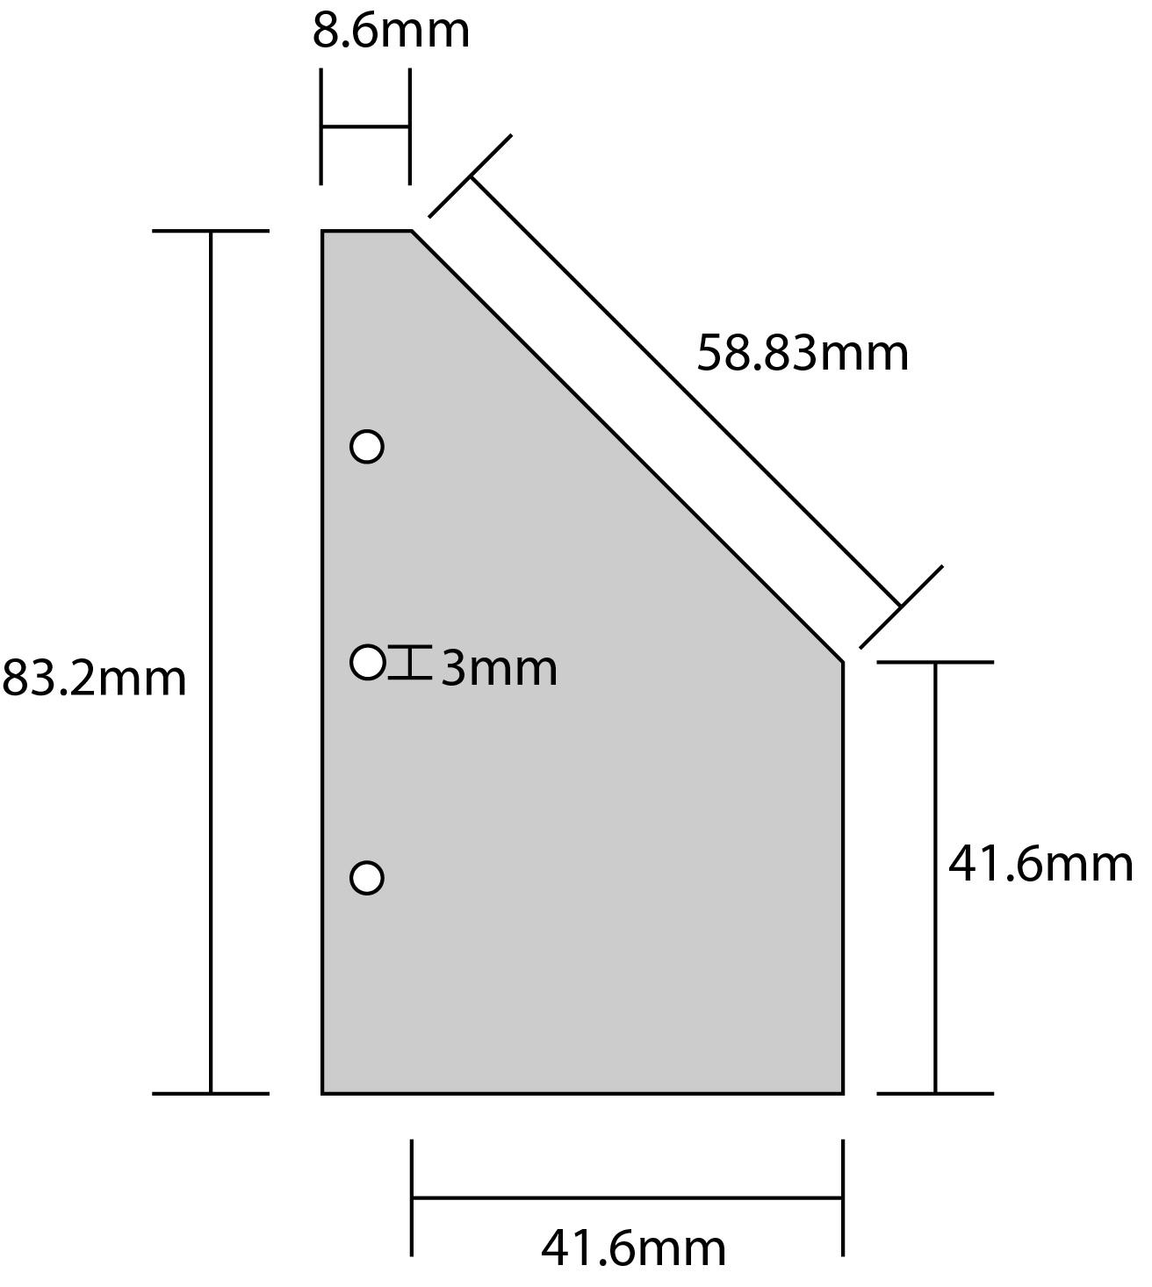
Diagram 1, Fin Dimensions
(fin thickness: Polycarbonate: 3mm; Delrin 150: 3.18mm; 7075 Aluminum: 3.18mm)

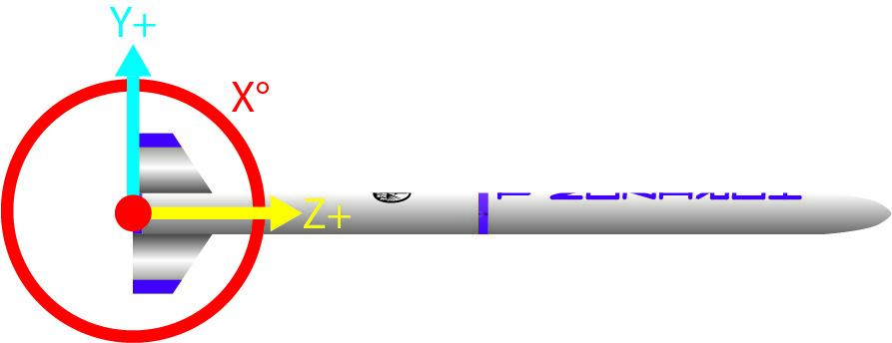
Diagram 2, Axis of Rotation as viewed along the X axis
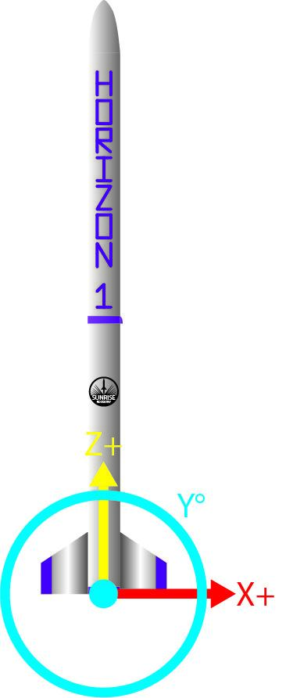
Diagram 3, Axis of Rotation as viewed along the Y axis

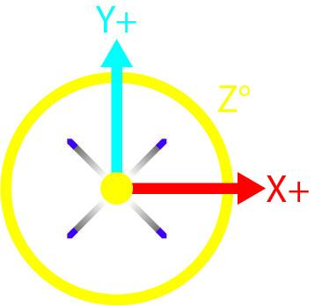
Diagram 4, Axis of Rotation as viewed along the Y axis

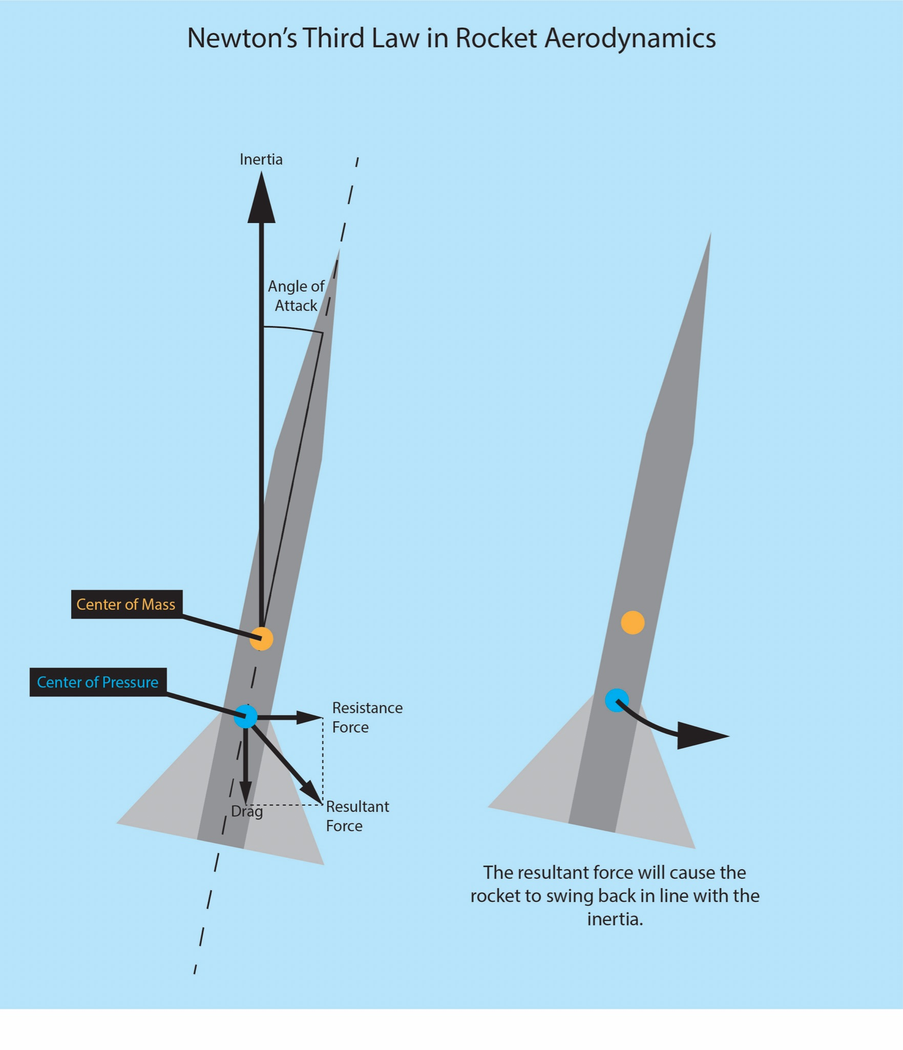
Diagram 5, Newton’s Third Law in Rocket Aerodynamics
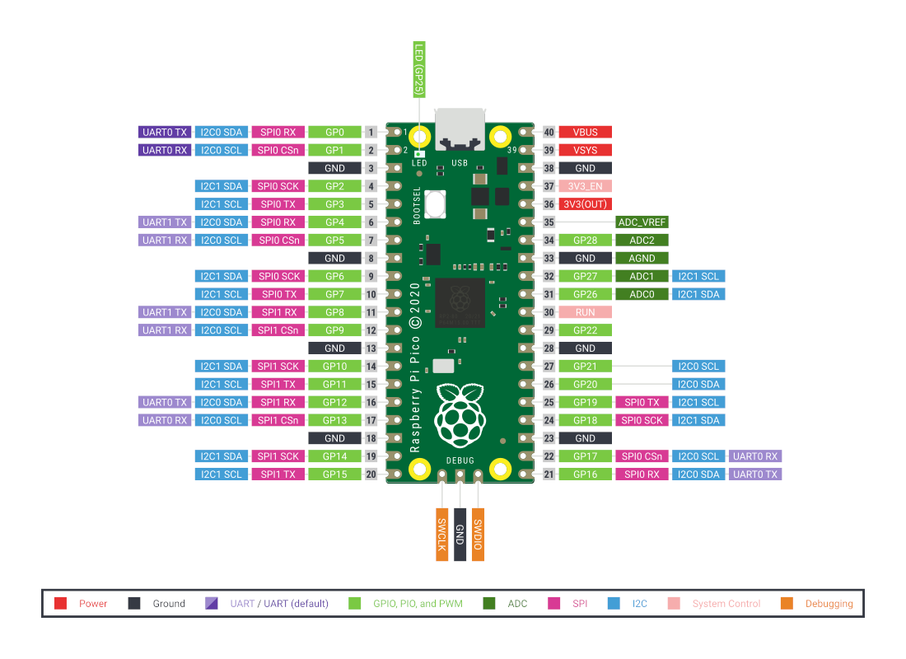
Diagram 6, Raspberry Pi Pico Pinout

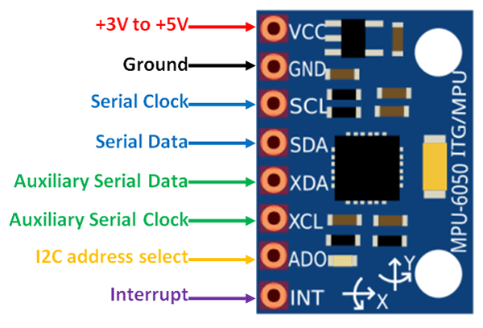
Diagram 7, MPU6050 Pinout
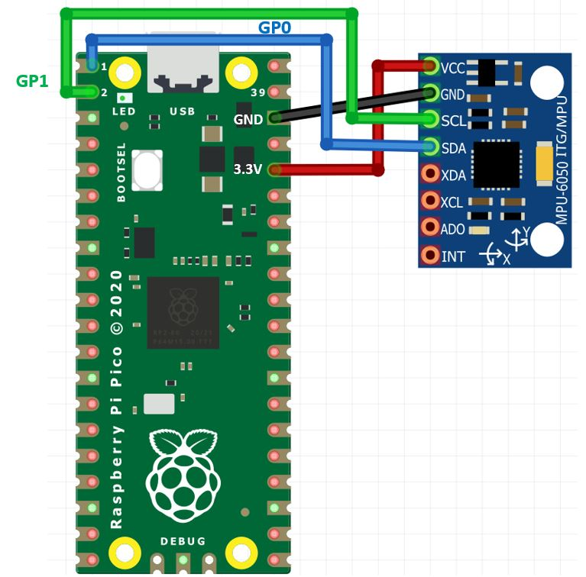
Diagram 8, Example Connection Wiring to Interface Raspberry Pi Pico and MPU6050
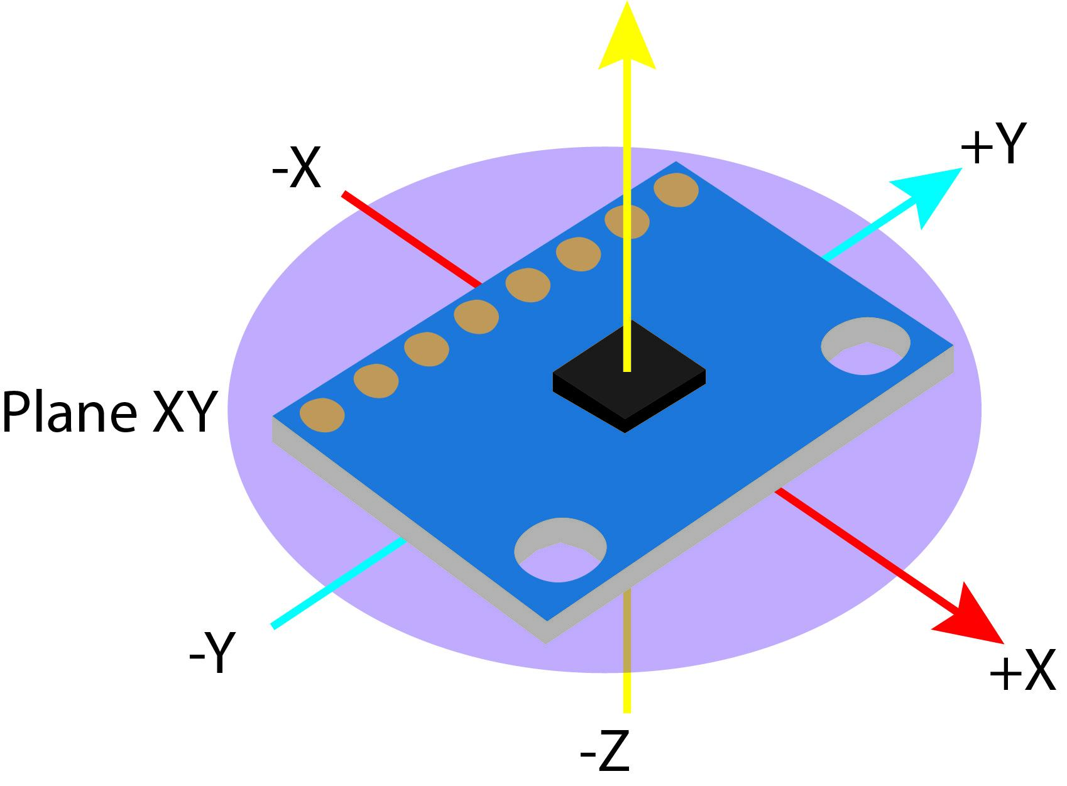
Diagram 9, MPU6050 X Y and Z Axis
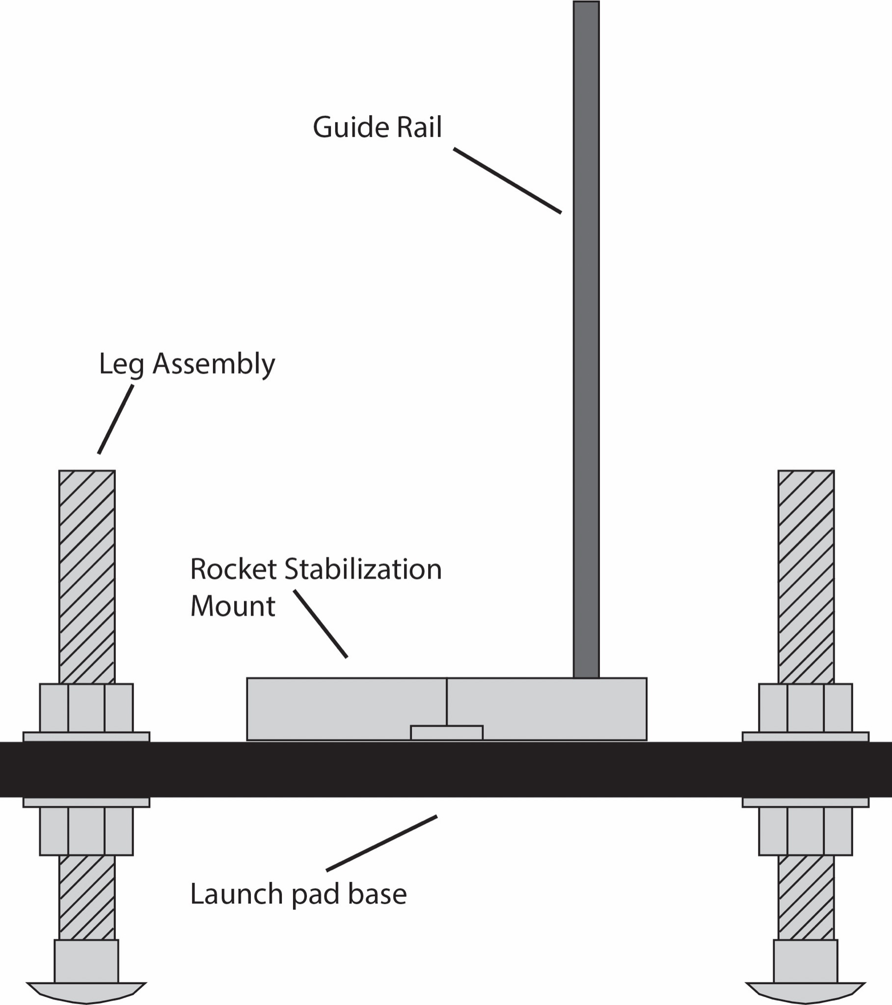
Diagram 10, Launch Pad
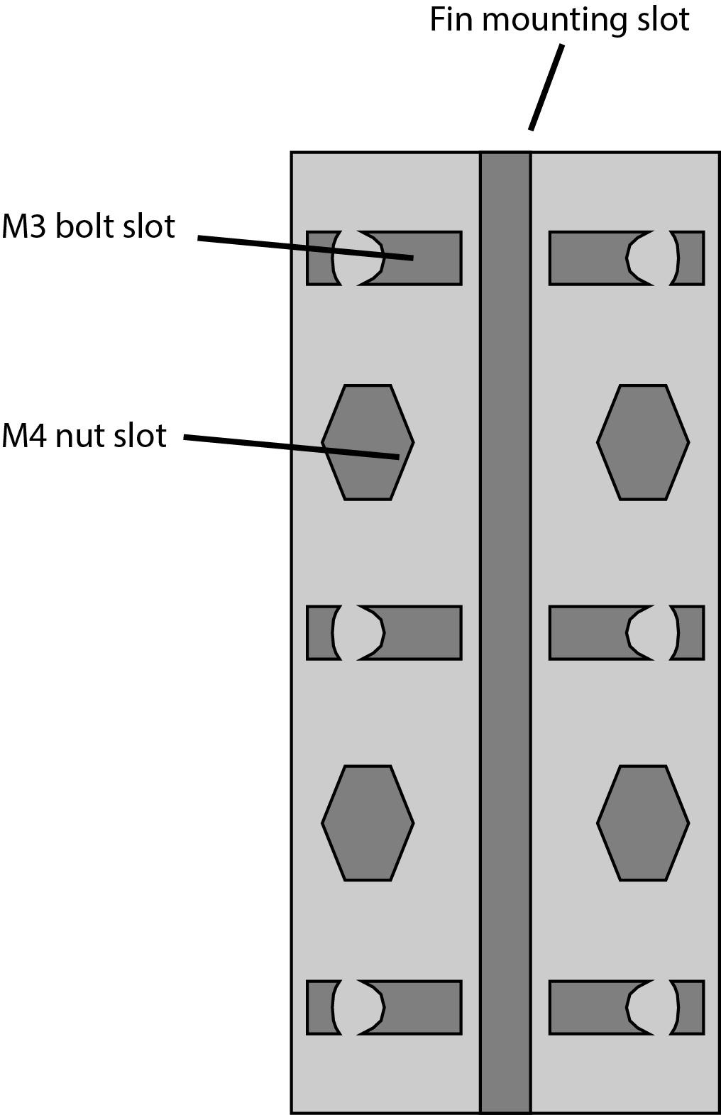
Diagram 11, Motor Mount Side View
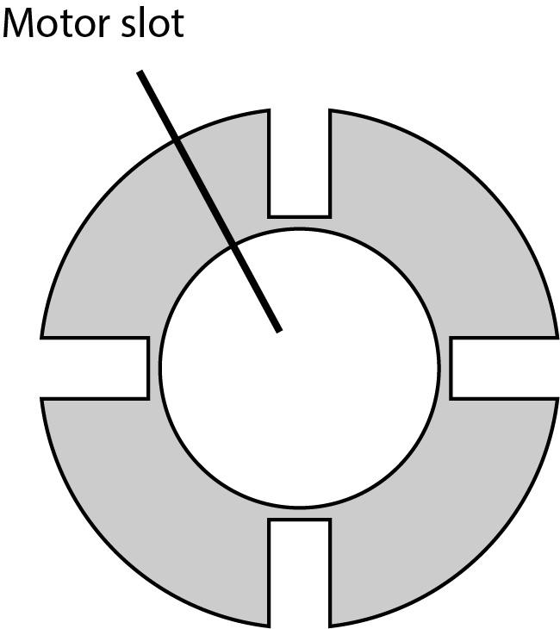
Diagram 12, Motor Mount Top View

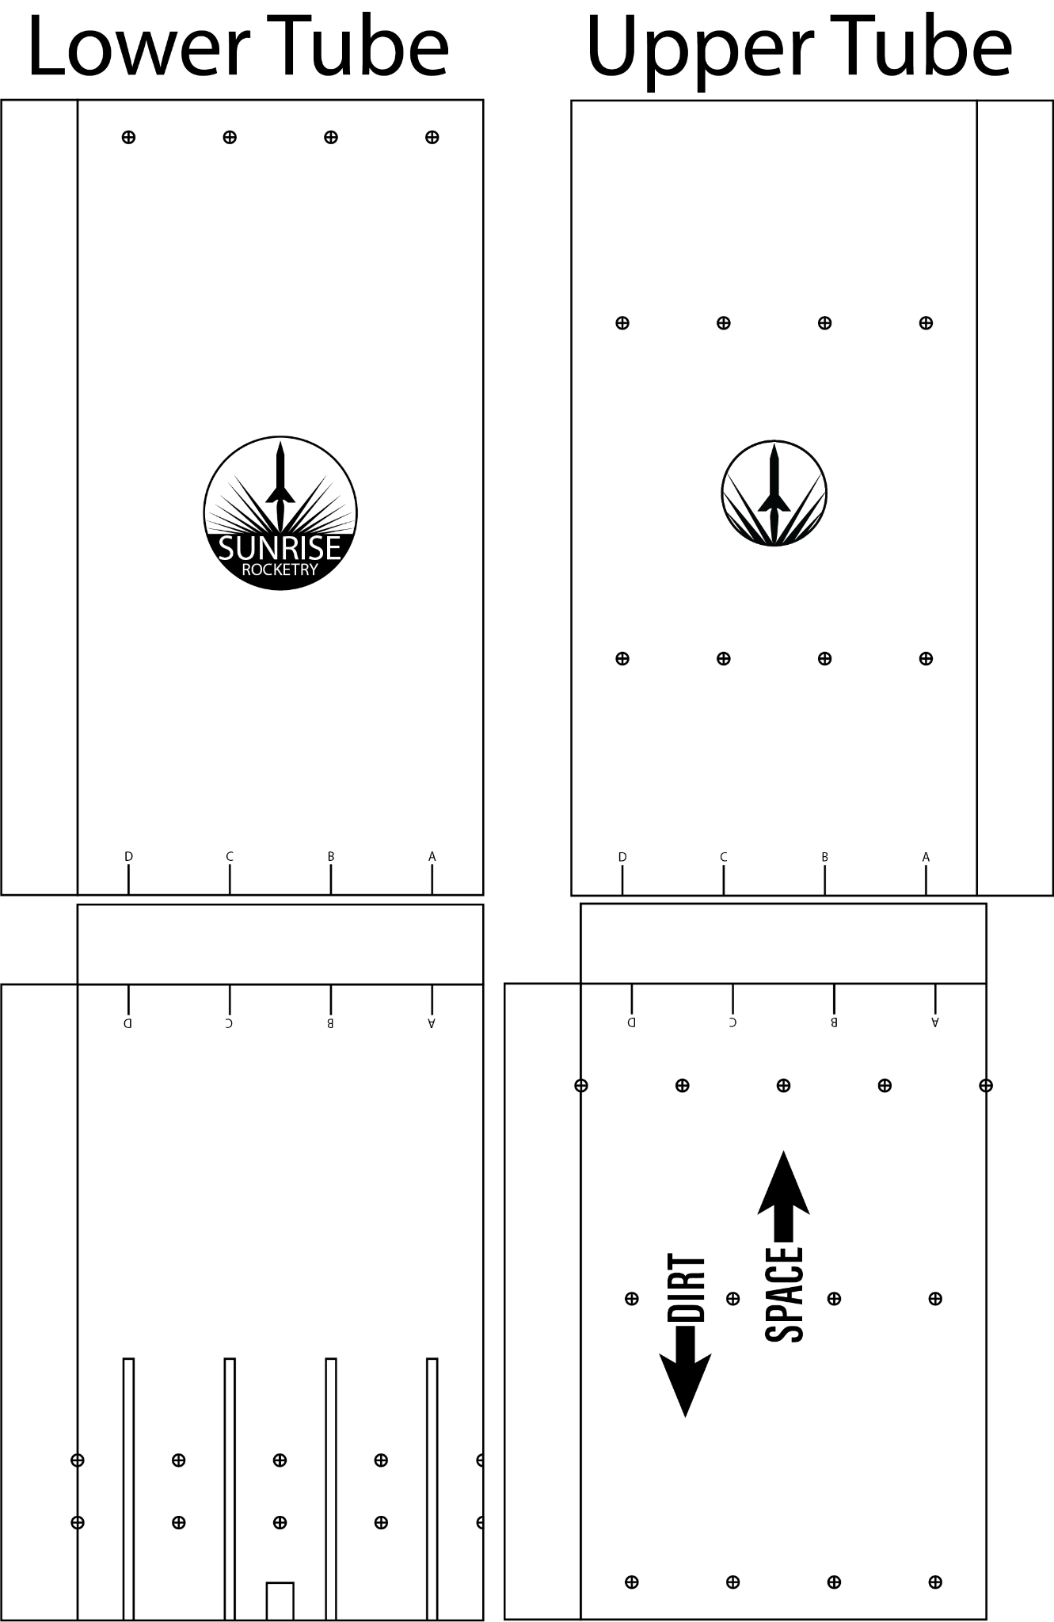
Diagram 13, Drill Alignment Stencils

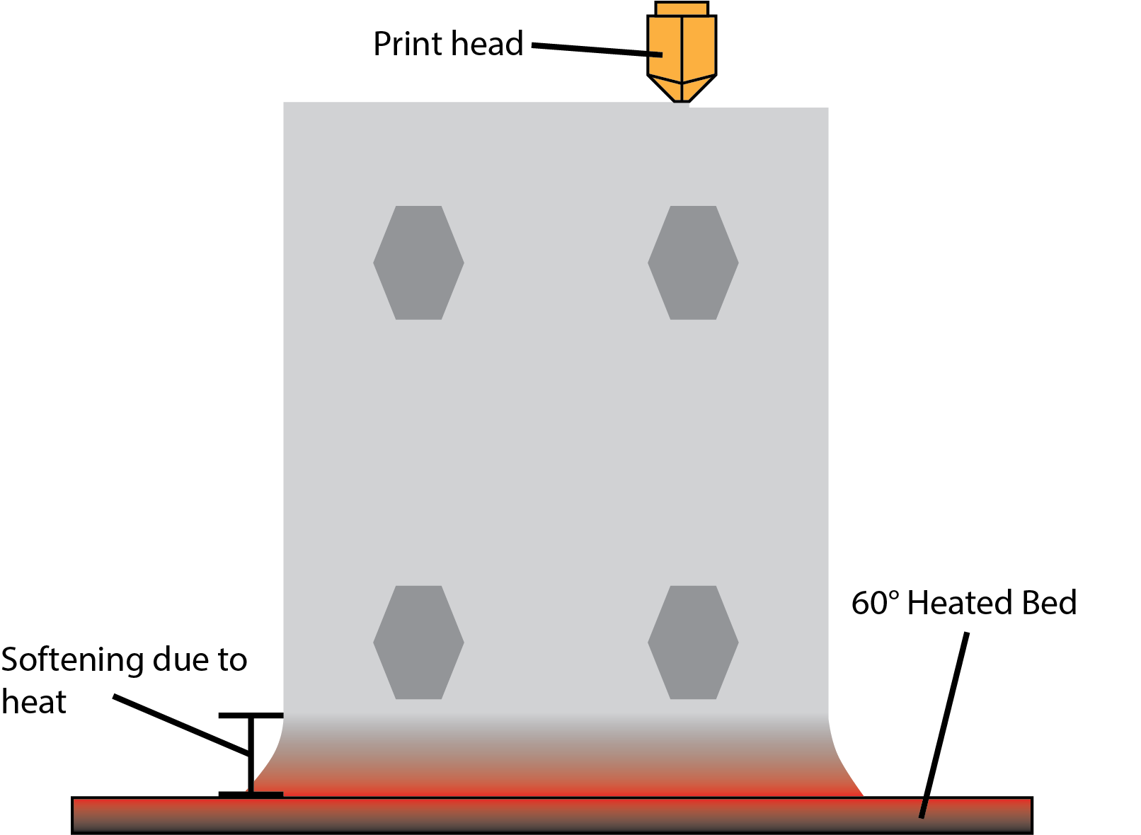
Diagram 14, Elephant’s Foot Effect During Printing

